**Python Code Challenges: Dictionaries (Advanced)**

**Difficult Python Code Challenges Involving Dictionaries**

This article will help you review Python functions by providing some code challenges involving dictionaries.

Some of these challenges are difficult! Take some time to think about them before starting to code.

You might not get the solution correct on your first try — look at your output, try to find where you’re going wrong, and iterate on your solution.

Finally, if you get stuck, use our solution code! If you “Check Answer” twice with an incorrect solution, you should see an option to get our solution code. However, truly investigate that solution — experiment and play with the solution code until you have a good grasp of how it is working. Good luck!

**Function Syntax**

def some_function(some_input1, some_input2):  
  … do something with the inputs …  
  return output

For example, a function that counts the number of values in a dictionary that are above a given number would look like this:

def greater_than_ten(my_dictionary, number):  
  count = 0  
  for value in my_dictionary.values():  
    if value > number:  
      count += 1  
  return count

And this would produce output like:

>>> greater_than_ten({"a":1, "b":2, "c":3}, 0)  
3  
>>> greater_than_ten({"a":1, "b":2, "c":3}, 5)  
0

**Challenges**

We’ve included 4 challenges below. Try to answer all of them and polish up your problem-solving skills!

**1. Word Length Dict**

Let’s start by writing a function that creates a new dictionary based on a list of strings. The keys of our dictionary will be every string in our list of strings, while the values will be the length of each of the words in the string list. Here are the steps:

1. Define the function to accept one parameter for our list of strings
2. Create a new empty dictionary
3. Loop through every string in the list of strings
4. Inside the loop, add the string as a key and the length of the string as the value to the dictionary
5. After the loop, return the new dictionary

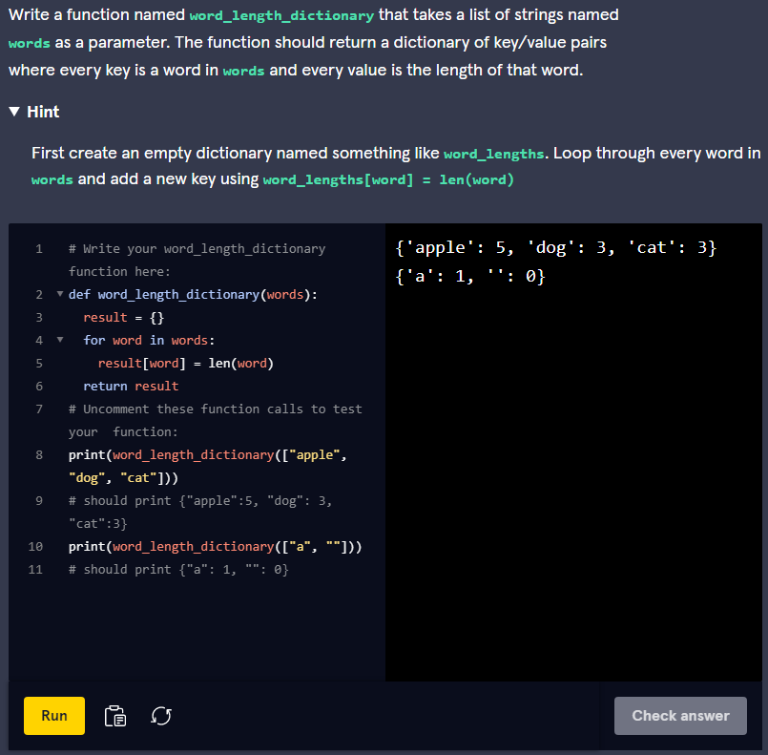

Here is this solution:

def word_length_dictionary(words):  
  word_lengths = {}  
  for word in words:  
    word_lengths[word] = len(word)  
  return word_lengths

To create a new dictionary we set a variable equal to **{}**. While iterating through each string in our string list, we can add the key and value to our dictionary using this syntax: **word_lengths[word] = len(word)**.

### 2. Frequency Count

This next function is similar, but instead of counting the length of each string in the list of strings, we will be counting the frequency of each string. This function will also accept a list of strings as input and return a new dictionary. Here is what we need to do:

1. Define the function to accept one parameter for our list of strings
2. Create a new empty dictionary
3. Loop through every string in the list of strings
4. Inside the loop, if the string is not already in our dictionary, store the string as a key with a value of 0 in our dictionary. Then, increment the value by 1.
5. After the loop, return the new dictionary

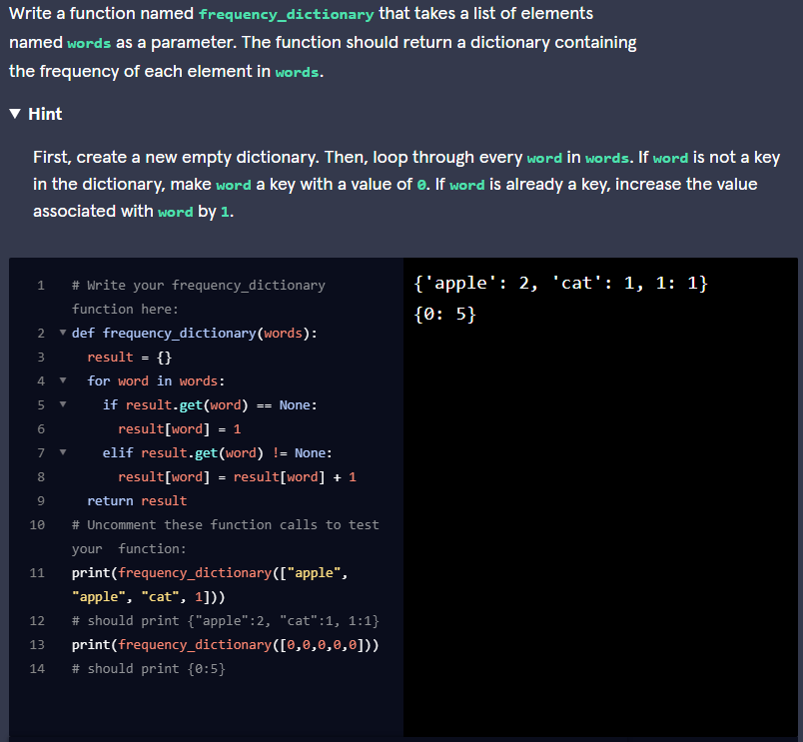

Here is how we solved it:

def frequency_dictionary(words):  
  freqs = {}  
  for word in words:  
    if word not in freqs:  
      freqs[word] = 0  
    freqs[word] += 1  
  return freqs

To create a new dictionary we set a variable equal to **{}**. We iterate through each of the strings in the list of strings and check if it is already in our dictionary using the **in** keyword. If it is not then we add it as a new key-value pair where the value is 0. Regardless of whether the string was already in the dictionary, increase the value by 1. This will make it so all new entries will have a value of 1 and all existing entries will increase their old value by 1.

### 3. Unique Values

Now let’s try reading a dictionary as input and finding how many values are unique. The function should return a number which is the count of all values from the dictionary without including duplicates. These are the steps:

1. Define the function to accept one parameter for our dictionary
2. Create a new empty list
3. Loop through every value in our dictionary
4. Inside the loop, if the value is not already in our list, append the value to our list
5. After the loop, return the length of our list

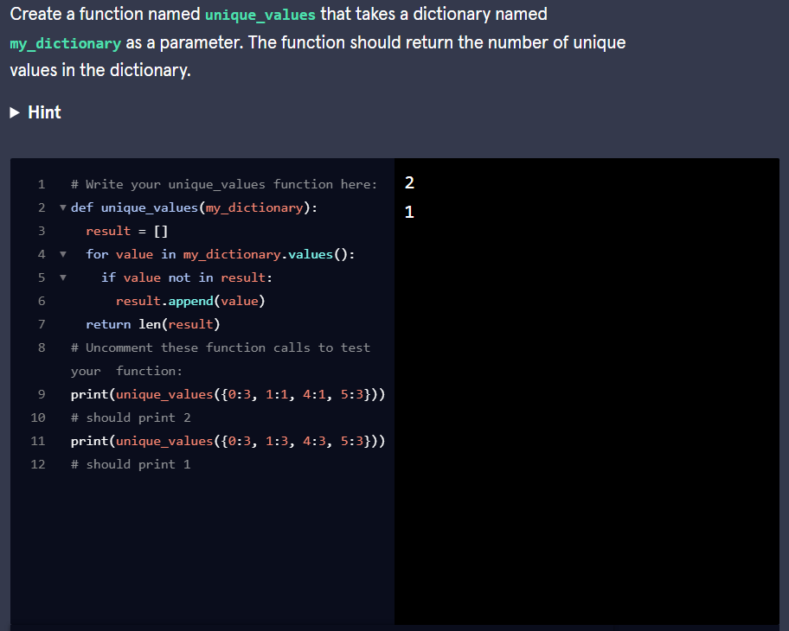

This function has a similar structure to the last one except that the input has been changed to a dictionary. We iterate through each of the values and whenever we find one we have not added to our list already, we add it to the list. After the loop, we return the length of the list since that contains all unique values from the dictionary.

### 4. Count First Letter

This function accepts a dictionary where the keys are last names and the values are lists of first names of people who have that last name. We need to calculate the number of people who have the same first letter in their last name. Here are the steps we need:

1. Define the function to accept one parameter for our dictionary
2. Create a new empty dictionary called **letters**
3. Loop through every key in our **names** dictionary
4. Inside the loop, get the first letter of the last name we are looking at. If the first letter is not in our letter dictionary, add it as a key with a value of 0. Then, increment that key by the number of people that have that last name
5. After the loop, return the **letters** dictionary